**VISVESVARAYA TECHNOLOGICAL UNIVERSITY**

**JNANA SANGAMA, BELGAVI – 590018**

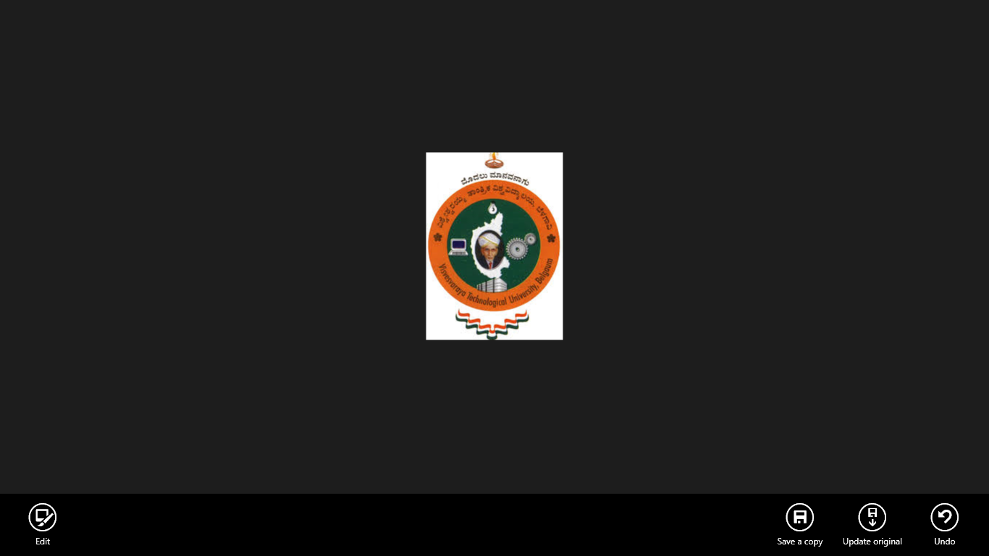

Mini Project Report On

**“DIGITAL WATERMARKING”**

*Submitted in partial fulfilment for the award of degree*

**Bachelor of Engineering**

In

**Electronics and Communication**

BY

**CHANDRASHEKHARAIAH M.M (1NH18EC709)**

UNDER THE GUIDANCE OF:

**Mr. PUVIRAJAN**

**Department of Electronics and Communication Engineering**

New Horizon College of Engineering





CERTIFICATE

Certified that the mini-project entitled “**DIGITAL WATERMARKING**” is carried out by  **CHANDRASHEKHARAIAH M.M**  bearing **USN:1NH18EC709** students of **NEW HORIZON COLLEGE OF ENGINEERING,BENGALURU**,in partial fulfilment for the award of Bachelor of Engineering in Electronics and Communication of the Visvesvaraya Technological University,Belgavi during the year **2020-2021**

It is certified that all corrections/suggestions indicated for Internal Assessment have been incorporated in the report deposited in the department library. The mini project report has been approved as it satisfies the academic requirements in respect of the mini project work prescribed for the said degree.

Signature of the HOD Signature of the Guide

Dr. Sanjeev Sharma Mr. Puvirajan

Professor & HOD Assistant professor

Dept. of ECE Dept. of ECE

NHCE, Bengaluru NHCE, Bengaluru

**EXTERNAL VIVA**

**Name of the Examiners Signature with date**

**1.**

**2.**

**ABSTRACT**

Digital domain offers various advantages over analogue like as high-quality editing, perfection in copying etc. So, this is more preferable now. It causes the large-scale unauthorised copying of music, book, film & software etc. so for giving protection from unauthorised copying we are using a unique mythology named DIGITAL WATER MARKING.

A Robust Watermark is more resilient to the tempering/attacks that multimedia object (Image, Video, and Audio) had to face like compression, image cropping, image flipping, image rotation to name a few.

Among the various information hiding technique, we have chosen digital water marking. To send secret information embedded in carrier multimedia object we use that method. The message may be text, audio, video or image. The hiding object may be visible or invisible. So, our goal is to provide an algorithm to increase the imperceptibility, robustness and data capacity for the digital water marking

**CONTENTS**

**CHAPTER 1:** Introduction

**CHAPTER 2:** Literature survey

**CHAPTER 3:** Technology used (Block Diagram)

**CHAPTER 4:** Proposed Methodology

**CHAPTER 5:** Result obtained

**CHAPTER 6:** Future scope

**CHAPTER7:** References

**CHAPTER 8:** Appendix

**CHAPTER 9**: Conclusion

**CHAPTER 1**

**INTRODUCTION**

The web may be a nice deals and dissemination channel for advanced resources, but copyright and substance the board is tested. Nowadays, computerised photos is used where with or while not assent. photos that ar spilled or abused will hurt advertising endeavors, complete image or finally deals. moreover, mentally property resources is disengaged from your copyright knowledge, therefore guarding brands and commissioned innovation resources is basic. Watermarking arrangements allow you to add further layer of assurance to your computerised photos.

WHAT IS DIGITAL WATER MARKING?

Computerized water checking implies concealing message known with a sophisticated sign like (picture, melody, video).digital watermarking is associate augmentation of this concept within the computerised world. computerised water stamping may well be noticeable during which case their utilization 2 overlay one is enfeeble unapproved use and second is act promotion. computerised watermarking works by the concealing knowledge within advanced data, that it cannot be distinguished with no extraordinary programming with purpose of making certain that shrouded data is obtainable all told duplicates of the knowledge that ar created lawfully or one thing else, ne'er the less of endeavors to evacuate it. There ar various types of advanced knowledge of knowledge like: i) Digital sound ii) Digital image iii) Digital video A watermark is example of bits embedded into a computerised image, sound or video record that acknowledges the documents copyright knowledge (creator, rights, so on) the name "watermark" is gotten from the faintly obvious imprints inscribed on association fastened. Not in any respect like written watermarks, that ar planned to be to a point obvious (like the sunshine compass stamp watermarking this report), advanced watermarks ar meant to be entirely unobservable, or on account of sound clasps, indiscernible. Furthermore, the bits talking to the watermark should be distributed in the course of the document so they can not be distinguished and controlled. Lastly, a computerised watermark should be powerful enough to endure changes to the document its established in. Advanced watermarking works by disguising knowledge within computerised data, to such associate extent that it cannot be distinguished while not exceptional programming to confirm the hid data is obtainable all told duplicates of the knowledge that ar created climate lawfully or one thing else, paying very little heed to endeavors to harm/evacuate it.

**HISTORY OF WATERMARKING**

The paper watermark previously showed up in 1282 in Italy. Everything began by adding a meager wire to the paper shape which was presented a straightforward imprint inside the paper (making the paper recognizable or to be utilized as trademark). The significance and motivation behind the most punctual watermarks are questionable. They may have been utilized for down to earth capacities, for example, recognizing the molds on which sheets of papers were made, or as trademarks to distinguish the paper producer. Then again, they may have spoken to supernatural signs, or may essentially have filled in as beautification. In the eighteenth century, the watermark on paper had gotten utilitarian in Europe and America. They were utilized as trademarks, to record the date that the paper was made and to show the creativity.

Around then the word watermark started to be utilized to recognize the antifraud quantifies on cash and different records. The word watermark was first utilized toward the finish of the eighteenth century. In 1779, the principal monetary certificate fraud was endeavored by John Mathison. Forging incited propels in watermarking innovation. William Congreve, an Englishman, imagined a method for making shading watermarks by embeddings colored material into the center of the paper during papermaking. The subsequent imprints more likely than not been incredibly hard to fashion, on the grounds that the Bank of England itself declined to utilize them in light of the fact that they were too hard to even think about making. An increasingly handy innovation was designed by another Englishman, William Henry Smith. This supplanted the fine wire designs used to make before marks with a kind of shallow help mold, squeezed into the paper design. The subsequent minor departure from the outside of the example delivered lovely watermarks with shifting shades of dark. This is the fundamental strategy utilized today for the substance of President Jackson on the $20 paper note. The word watermark may have been procured from the German expression wassermarke, which implies watermark in English. The translation of the word watermark is most likely a reference with the impact of water on the paper. A model watermarking in early history is the subtle messages about the items where they are installed. Another case of watermarking is in the field of music. A U.S. patent (1961) depicts another development for forestalling theft. The watermark was actualized by embeddings an ID code in the music by discontinuously applying a thin step channel focused at 1 kHz. The nonattendance of vitality at this recurrence showed to an unscrambling code either a speck or a scramble. The distinguishing proof sign utilized the Morse code. This innovation is like the computerized strategies utilized in the current day.

Advanced watermarking continuously developed until it was acknowledged as a type of copyright security. In 1979, Szepanski portrayed a machine-perceptible example that could be put on archives for against duplicating purposes. After nine years, scientists depicted a technique for implanting a recognizable proof code in a sound sign. In 1988, scientists initially utilized the term advanced watermark. In the mid 1990s the term advanced watermarking increased all inclusive worthiness. In 1996, the main Information Hiding Workshop (IHW) was held, which included computerized watermarking as one of its essential subjects. At that point more meetings explicitly to security and watermarking of interactive media substance were dedicated in 1999. During this time numerous associations started considering watermarking innovation for consideration in different norms.

The Copy Protection Technical Working Group (CPTWG) tried watermarking frameworks for assurance of video on DVD plates. Additionally the assurance of music and sound frameworks was presented by the Secure Digital Music Initiative (SDMI). The propelled MPEG guidelines were additionally made by the International Organization for Standardization (ISO). A few organizations were associated with watermark innovation and licensed innovation security, including sounds, pictures and video. In the region of picture watermarking, for instance, Dig marc utilized the implanted watermark and identification innovation with Adobe's Photoshop. In the late 1990s watermarked items turned out to be commonly accessible.

**PROPERTIES OF DIGITAL WATERMARKING**

Advanced picture watermarking worries to tackle a few issues appropriately, therefore, this paper features the principle necessities of watermarked picture as following:

**Power**: The vigor is the capacity of distinguishing the watermark after some sign preparing change, for example, spatial sifting, checking and printing, lossy pressure, interpretation, scaling, and pivot, and different activities like computerized to simple (D/A), simple to advanced (A/D) transformations, cutting, picture upgrade. Furthermore, not all watermarking calculations have a similar degree of heartiness, a few procedures are vigorous against some control tasks, in any case, they come up short against other more grounded assaults. Also, it's not constantly attractive for watermark to be hearty, sometimes it's ideal for the watermark to be delicate. Consequently, the vigor can be named following:

• **Robust**: The watermark is intended to have the option to make due against coincidental and purposeful assaults. This sort of watermarking can be utilized in communicate checking, copyright security, fingerprinting, and duplicate control.

• **Fragile**: The watermark in this sort is intended to be annihilated at any sort of alteration, to distinguish any unlawful control, even slight changes, including coincidental and deliberate assaults. Delicate watermarks are for the most part utilized in content confirmation and trustworthiness check. They utilize daze discovery type, as it will be talked about in Detection Types. What's more, the usage of delicate procedures is simpler than the execution of hearty ones.

**Semi-delicate**: The watermark in this sort is hearty against accidental changes, yet delicate against vindictive assaults and it is utilized for picture verification.

**Intangibility**: Imperceptibility (otherwise called Invisibility and Fidelity) is the most huge necessity in watermarking framework, and it alludes to the perceptual similitude between the first picture before watermarking process and the watermarked picture. At the end of the day, the watermarked picture should seem to be like the first picture, and the watermark must be imperceptible regardless of event of little debasement in picture differentiation or brilliance. In any case, the test is that impalpability could be accomplished, however the strength and the limit will be diminished, and the other way around, intangibility might be relinquished by expanding the heartiness and the limit. In addition, the watermark not constantly wanted to be imperceptible, now and then, it is liked to have noticeable watermark into the picture.

**Limit**: Capacity (otherwise called Payload) alludes to the quantity of bits implanted into the picture. The limit of a picture could be distinctive as indicated by the application that watermark is intended for. Additionally, considering the limit of the picture can show us the restriction of watermark data that would be installed and simultaneously fulfilling the subtlety and strength.

**Security**: Security is the capacity to oppose against purposeful assaults. These assaults expected to change the reason for inserting the watermark. Assaults types can be isolated into three fundamental classifications: unapproved evacuation, unapproved inserting, and unapproved recognition. As indicated by the particular use of watermarking, the particular element ought to be accessible in the watermark to oppose the assaults. In this manner, for unapproved expulsion, the watermark ought to be powerful and not to be expelled, and for unapproved implanting (otherwise called phony), the watermark ought to be delicate or semi delicate to identify any alteration. In conclusion, for unapproved discovery, it should be impalpable watermark.

**Low Complexity**: The expense is the purpose for considering the intricacy, so it ought to be at a sensible expense. It depicts the financial matters of utilizing watermark embedders and finders, since it very well may be confounded and relies upon plan of action that is utilized. The principle two issues of multifaceted nature are the speed of implanting and identification, and the quantity of embedders and finders.

### CLASSIFICATION OF INFORMATION HIDING TECHNIQUE

**Information Hiding**

Covert channel

Steganography

Copyright Marking

Storage channel

Timing channel

Digital

Technical

Linguistic

Steganography

Steganography

Steganography

Semagram

Open code

Digital

Cryptographic

• **ANONYMITY**:

Namelessness implies anonymously or having a pseudo name. It is an investigation of discovering approaches to conceal the substance (for example the sender and the beneficiaries) of a message. We won't clarify considerably more on this theme. Since our objective is reach to the watermarking innovation.

• **COVERT CHANNEL**:

An incognito channel is escaped the entrance control component working framework that can't be identified of constrained by the hard product based security system.

Incognito channel can be utilized for a solitary framework just as for a system too. It is of two kinds – Storage Channels and Timing Channels, regardless of whether stockpiling channels are more normally utilized than the other one. The fundamental downside of this data concealing plan is the low Signal-to-Noise proportion, low information rates and it can frequently be recognized by checking the framework execution.

• **STEGANOGRAPHY**:

Greek word 'Stegano' signifies secured or ensured and 'Graphia' signifies composing. Stegaaphy is the craftsmanship or practice of disguising a mystery data, in type of a message or picture or record inside another message, picture or document.

As said before steganography is of three kinds Technical steganography, Linguistic steganography, Digital steganography.

The models given in the area of history of data stowing away, gives a thought regarding the specialized steganography.

• **OPEN CODE**:

use deceptions or code word. ' Hypnerapomachia Poliphili' is an appropriate case of open code steganography is likewise depicted in history partition.

• **SEMAGRAM**: is a mystery code which isn't in composed structure like melodic documentations.

Presently go to the ongoing exchange of steganography-Digital steganography. Electric correspondence may incorporate steganography coding within a vehicle layer, for example, a report, or picture or convention. This procedure is named as the advanced steganography.

### IMPORTANCE OF WATERMARKING

The accessibility of PCs and simple access to the web has lead to a noteworthy increment in the downloading of advanced media documents. These computerized records can be pictures, music, recordings and different archives. The web became easy to use with the presentation of the main broadly utilized internet browser in November 1993. The web is a fantastic circulation framework for advanced media since it is cheap and permits helpful downloading and sharing among people and associations. In this way, replicating and changing these records and archives have gotten well known. The illicit replicating of certain sorts of media has been a subject of worry for a long time. Thus, a dire answer for copyright insurance and validation is required. Computerized watermarking is a successful answer for secure scholarly properties and copyrights by concealing data, for example, logos, marks or content into sight and sound information, for example, pictures, recordings, or sound documents. Notwithstanding, content proprietors (particularly enormous Hollywood studios and music names) additionally observe a high danger of robbery. Previously, utilizing simple gadgets represented a lower chance than with advanced media; duplicating a simple record permits brings about a corruption of the quality. Be that as it may, with computerized media recording gadgets, tunes and motion pictures can be created with no corruption at all in quality, since the information are a flood of 1's and 0's.

Utilizing computerized gadgets and interfacing them to the web, individuals can record and disperse copyrightprotected material without come back to the lawful substance proprietors, nor pay them for their endeavors. Genuine land owners began looking for a certified technique to secure their privileges. Cryptography is likely the most widely recognized strategy for securing computerized content. By utilizing this innovation, items are encoded before sell, and just individuals who bought these have the unscrambling key to completely get to the scrambled documents. The scrambled records can likewise be made accessible through the Internet. Tragically, venders can't screen how an authentic client handles the substance after decoding. When the first duplicate is sold, a privateer can really buy the item, utilize the unscrambling key to get unprotected duplicate substance, at that point imitate various duplicates for illicit circulation.

So cryptography gives a restricted proportion of assurance; when the decoded content arrives at the client there will be no further security. In this way, there is as yet a requirement for additional assurance of substance, much after it is decoded. Watermarking is a promising innovation that can be utilized to satisfy the proprietor's copyright assurance. In advanced watermarking, the data is hided inside the substance. Computerized watermarking can endure various types of assaults, incorporate pressure, advanced to simple transformation, and record design changes. A watermark can be intended to endure these procedures. Watermarking has been considered for some duplicate anticipation and copyright insurance applications. In duplicate counteraction, the watermark might be utilized to advise programming or equipment gadgets that replicating ought to be confined. In copyright security applications, the watermark might be utilized to recognize the copyright holder and guarantee legitimate installment of eminences. Despite the fact that duplicate anticipation and copyright insurance have been significant main thrusts behind research in the watermarking field, there are various different applications for which watermarking has been utilized or proposed. These incorporate communicate checking, exchange following, and validation. Different applications that require still picture watermarking incorporate clinical pictures, satellite pictures, and picture caught by cell phone cameras.

### WATERMARKING MODELS

There area unit a few of manners by that we are going to demonstrate a watermarking procedure. These are extensively organized in one in each of two gatherings. the foremost gathering contains models that deem a correspondence primarily based perspective on watermarking and conjointly the following gathering contains models passionate about a geometrical perspective on watermarking. among the rest of this text, I merely bit to image watermarking in light-weight of the particular incontrovertible fact that I merely focused on footage throughout the advancement of model watermarking frameworks. Correspondence primarily based models: Correspondence primarily based models portray watermarking during a} very manner essentially identical as a result of the customary models of correspondence frameworks. Watermarking is basically a procedure of transmission a message from the watermarking embedder to the watermarking recipient. Hence, it bodes well to utilize the models of secure correspondence to demonstrate this procedure. during a} very general secure correspondence model we would have the sender on one side, which could code a message utilizing associate committal to writing key to forestall busybodies to decipher the message if the message was caught throughout transmission. At that point the message would be transmitted on associate interchanges channel, which could add some clamor to the commotion to the encoded message. the subsequent loud message would be gotten at the opposite finish of the transmission by the beneficiary, which could arrange to unravel it utilizing a translating key, to recover the first message. This procedure are found among the conventional model of a correspondences channel with key-based committal to writing once all is alleged in done, correspondence primarily based watermarking models are besides partitioned into two sub-classes. the foremost uses side-data to upgrade the procedure of watermarking and conjointly the second doesn't utilize side-data by any stretch of the imagination. The term side data alludes to any assistant data with the exception of the information message itself, which is able to be used to any or all the extra probably code or disentangle it. the best case of typically|this can be} often the image accustomed convey the message, which can be used to supply helpful data to upgrade the correct discovery of the message at the recipient. Geometric models: It is typically helpful to ponder watermarking in geometric terms. throughout this sort of model, pictures, watermarked and unwatermarked, are seen as high-dimensional vectors, in what is mentioned because the media house. typically|this can be} often besides a high-dimensional house that contains every single potential image everything being equal. for instance, a 512 X 512 image would be pictured as a 262144 elements vector during a} very 262144-dimensional house. Geometric models are helpful to further promptly imagine the watermarking procedure utilizing varied areas passionate about the tempting properties of watermarking. one in each of those areas is that the inserting district, that's that the locus that contains all the potential footage materializing as a results of the implanting of a message among associate unwatermarked image utilizing some watermark fitting calculation. Another necessary area is that the placement locus, that's that the district containing all the potential footage from that a watermark are effectively free utilizing a watermark recognition calculation. Ultimately, the locus of adequate devotion contains all the potential footage materializing as a results of the fitting of a message into associate unwatermarked image, that primarily appear to be indistinguishable from the first image. The inserting area for a given watermarking framework need to during a} very wonderful world lie among the convergence of things district and conjointly the locus of satisfactory loyalty, so on deliver effectively distinguished watermarks that don't modification the image quality whereas not a doubt. Here we are going to see that if mean sq. blunder (MSE) is used as a proportion of devotion, the district of adequate constancy would be a ndimensional circle fixated on the first unwatermarked image (co), with a span defined by the biggest MSE we've got a bent to stand live happy to acknowledge for footage with worthy loyalty. the invention district for associate identification calculation passionate about direct affiliation would be defined as a zero.5 house, in light-weight of the sting accustomed choose whether or not or not a picture incorporates a watermark place in or not. Note that the graph is solely a projection of a ndimensional house into a second house. The district of satisfactory constancy (characterized by MSE) and conjointly the identification area (characterized by direct relationship) once considering sophisticated watermarking frameworks, it's presently and yet again progressively valuable to ponder a projection of the media house into a probably lower-measurement checking house throughout that the watermarking at that point happens in spite of everything. This projection are addressed all the extra effectively by PCs in view of the shorter sort of vector elements and can be communicated by sq. primarily based watermarking calculations that separate footage into obstructs as essential working on an image component premise.

### 

**CHAPTER 2**

**LITRATURE SURVEY**

1. In 1996 I.J. Cox et al. presented a recurrence area water mark conspire utilizing spread-range method. The expectations of the plan were to embed watermarking into the specific unearthly parts of the sign which are perceptually most significant.by figuring the DCT of the whole picture, the most noteworthy locales are set apart out. At that point the watermark (here, utilized as grouping of genuine numbers with an ordinary appropriation N (0, 1) and having a zero mean and 1 difference) is embedded into the DCT space of the stamped position of the general sign handling and geometric interruption. To make it vague in any recurrence shaft cox et al.spread it over brod band.but the downside conspire is that it needs the first picture for its extraction. All the more ever, creator didn't explain whether it is roboust again copying assault or not.

Another human visual system based watermarking technology was prepared by kim al in 1999.but here instead of DCT wavelet transform was used. Here the energy of each wavelet bands have been calculated and according to this the number of watermark sequence changes proportionally. The changing rate of a sinusoidal pattern per subtended visual angle (unit-cycle per degree is the estimation of image characteristics as well as the visual weight of watermarking in each wavelet transfer band.

1. A spatial domain invisible digital watermarking technique was proposed by R.B walfagang and E.J.delp in 1997.here the watermark was a combination of two dimensional blocks of a long row-by-row m-sequence ,having the same size of the image.in this scheme additionally the author used a testing paradigm with different ranges using which the authentically of the image could br determined.
2. I.J. Cox was followed by W.Zhu et al. with a little difference in the algorithm.in 1999 Zhu et al.developed this watermarking algorithm inserting the watermarking in wavelet coefficient and the watermark which

**CHAPTER 3**

**TECHNOLOGY USED**

Essentially it's the strategy to implant an information (called watermark) into AN item (known as host image or unfold article) so modification will not be permissible.

It for the foremost half contains of 2 stages. i) Watermark inserting method ii) Watermark extricating method.

Inserting or encoding: In the hour of inserting a watermark, it's wished to accomplish the best sincerity even as vitality. to spice up the sign vitality planner ought to arrange to diminish the error rate. Here AN encoder work (FE) installs the watermark (W) into {a image|an image} (IO) and produces the watermarked picture (IW). the overall sq. chart of a elementary watermark putting in framework is appeared in Figure one.

The water mark technique is invented as well as fruitful in information hiding scheme because we don’t have a perfect visual system to detect a slight change and to distinguish it from the original one.

**W**

**I W**

**FE**

**Figure 1 : Block diagram of watermark embedding system**

**Extracting or decoding:**

The purpose of the extraction of an image is to determine the water mark. In this procedure the original image (IO) is given to the input extracting function (FD) and as another input the received image i.e. the watermarked image (IR) is applied. As an output of the decoder, a watermark (W’) is obtained. Then to check whether the watermark is original or not, W’ is compared to the original watermark (W) through a comparator function (FC) applying a certain threshold value. In fig.2 the extracting process of a watermark is shown in Figure 2.

**R**

**W**

**FC**

**W’**

**FD**

I**R**

**Figure 2: Block diagram of watermark extracting**

**CHAPTER 4**

**PROPOSED METHODOLOGY**

For information hiding, various techniques are there. But as a copyright protection mechanism, we have chosen Digital Watermarking for some several facilities mainly,

1. Watermark is imperceptible so that the cover will not be detracted in the aesthetic sense.
2. The watermark and the cover into which it is embedded are inseparable (Even if the after conversion of the cover into another file format, the watermark is not being eliminated or destructed).

We have to generate such a watermarking algorithm which provides better robustness, imperceptibility and data capacity. Although the above three features cannot be increased all at a time. Because, as discussed robustness means the property for which an information embedded in an object will try to remain unchanged. So if data quantity increased it will be harder to make them robust. Again it is also difficult to make a larger amount of data imperceptible. The property robustness also opposes to imperceptibility. A relative characteristic of these three main property of digital watermarking is shown in Figure 3.

[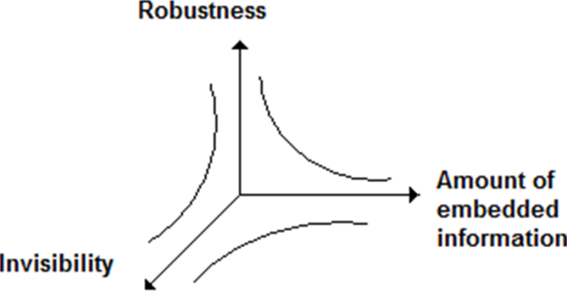](https://www.google.co.in/url?sa=i&rct=j&q=&esrc=s&source=images&cd=&cad=rja&uact=8&ved=2ahUKEwj_jrjZ28LhAhWJfisKHUhLCqAQjRx6BAgBEAU&url=https%3A%2F%2Fwww.intechopen.com%2Fbooks%2Fdiscrete-wavelet-transforms-algorithms-and-applications%2Fwatermarking-based-image-authentication-system-in-the-discrete-wavelet-transform-domain&psig=AOvVaw07KnlxsppRBatqkYZATx2c&ust=1554889169408292)

**Figure 3. Relationship between Robustness, Imperceptibility, Data Capacity**

So, we have to make an algorithm (having balanced robustness, imperceptibility and data capacity) to prove that it is a better approach by compare it to the others.

The proposed work consists of

1. Invisible Watermarking

2. Spatial Domain Analysis

3. Increasing of Robustness, Imperceptibility and Data Capacity

It is done using 2 basic operations:

1. **Saliency Mapping:** It works based on the visual saliency i.e. the portion of any image is mostly observed by human eye, and we should not enter the watermark into these places to increase the Robustness and Imperceptibility of the image.

[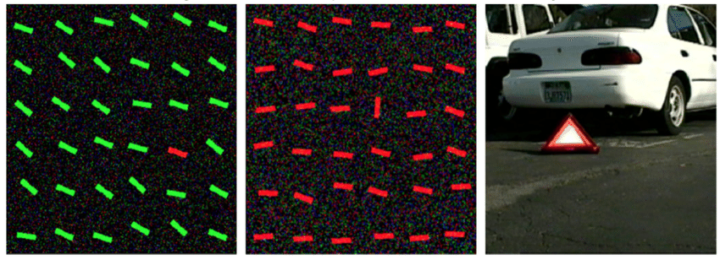](https://www.google.co.in/url?sa=i&rct=j&q=&esrc=s&source=images&cd=&cad=rja&uact=8&ved=2ahUKEwjLq_S-3sLhAhWOA3IKHcr3AKoQjRx6BAgBEAU&url=https%3A%2F%2Fwww.researchgate.net%2Ffigure%2FExamples-of-visual-saliency_fig1_320084588&psig=AOvVaw32nR10YKr60fkiCzMjSJx_&ust=1554889858529304)

**Figure 4**

One item in the array of items strongly pops-out and effortlessly and immediately attracts attention. Many studies have suggested that in simple displays like this, no scanning occurs: Attention is immediately drawn to the salient item, no matter how many other items (called distractors) are present in the display. This suggests that the image is processed in parallel (all at once) to determine saliency at every location and to orient towards the most salient location.

[](https://www.google.co.in/url?sa=i&rct=j&q=&esrc=s&source=images&cd=&cad=rja&uact=8&ved=2ahUKEwjfsv7e38LhAhWUfCsKHbTvBbYQjRx6BAgBEAU&url=%2Furl%3Fsa%3Di%26rct%3Dj%26q%3D%26esrc%3Ds%26source%3Dimages%26cd%3D%26ved%3D%26url%3Dhttps%253A%252F%252Fwww.researchgate.net%252Ffigure%252FExamples-of-visual-saliency_fig1_320084588%26psig%3DAOvVaw0in0UbA1bZ5PdfW5XI69Tz%26ust%3D1554890023246801&psig=AOvVaw0in0UbA1bZ5PdfW5XI69Tz&ust=1554890023246801)

**Figure 5**

In this display, the vertical bar is visually salient. Comparing this example to the previous one suggests that local visual properties of a given item do not determine how perceptually salient this item will be; rather, looking at a given item within its surrounding context is crucial. Compare, for example, the red bar in the top-left corner of this image to the salient bar in the image above: both bars are red, roughly horizontal, and they both have very similar local appearances. Yet the one in the top-left corner here has low saliency and attention is much more strongly attracted to the more salient vertical bar, while the red bar in the above image is highly salient.

[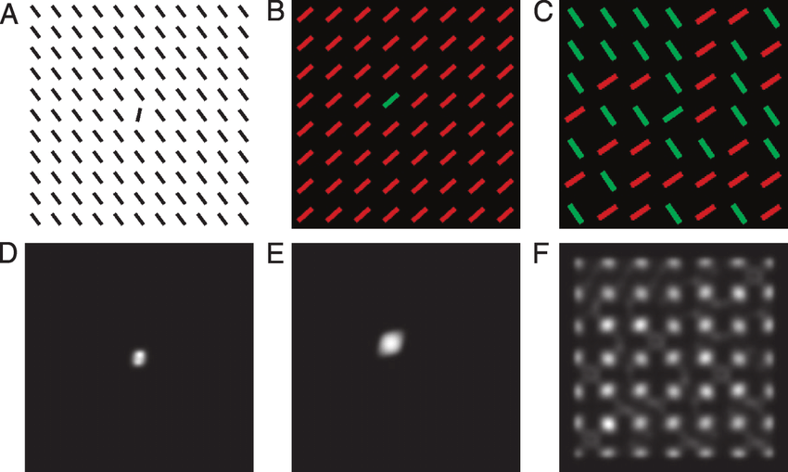](https://www.google.co.in/url?sa=i&rct=j&q=&esrc=s&source=images&cd=&cad=rja&uact=8&ved=2ahUKEwiM-dLx4sLhAhVJOisKHXFRDowQjRx6BAgBEAU&url=https%3A%2F%2Fwww.researchgate.net%2Ffigure%2FDiscriminant-saliency-output-bottom-row-for-displays-top-row-where-target-and_fig2_23790302&psig=AOvVaw1aGNDX7GYH1zZdbQMxnVuC&ust=1554891096856753)

**Figure 6**

In this display, there is again one bar that is unique and different from all the other ones. However, by design and through judicious choice of distracting items, there is little saliency to guide you towards the target bar (why that is will be discussed in the following section). The target is a so-called conjunction target: is the only red and vertical bar. Because saliency does not help you direct attention towards potentially interesting items in the display, you find yourself scanning the image, seemingly at random, looking for something interesting

**2. Hiding Capacity Map (HCM)**: This technique divides the whole image into some portions based on Saliency and JND to guide the user where to enter the most bits of the watermark and where to enter less no of bits of the watermark.





**CHAPTER 5**

**RESULT OBTAINED**







**CHAPTER 6**

**FEATURE SCOPE**

* The robustness can be measured.
* If needed, algorithm can be modified to increase robustness.
* A detailed comparison study with respect to other algorithm can be done.
* work with 3-D images can be done.
* Watermarking process can also be done with text or audio files.
* More Statistical Parameters can be analysed.

**APPLICATION**

• **Copyright Protection**: The most particular use of advanced watermarking is copyright security. As bunches of interactive media objects are traded over uncertain system without fail, the copyright assurance has become an essential issue. Since for accessibility of the pictures through web, these will be utilized without installment of sovereignty. Thus, watermark going about as a proprietorship imprint can limit the redistribution of the article.

• **Content Protection**: If a substance (like library composition) stepped with a strong and obvious watermark, it will show the proprietorship unique. In this way, the substance can be made accessible through the web and be conveyed all the more unreservedly and openly.

• **Content Labeling**: Watermark may convey more data about the article like quality, maker's depiction and so forth. This is known as substance marking.

• **Authentication**: In certain applications like ATM cards, ID cards, Credit cards and so forth., the responsibility for contain must be checked. This quarry can be illuminated by inserting a watermark and furthermore by giving the proprietor a private key to get to the message.

• **Evidence of Ownership**: Invisible watermarking may likewise use in copyright assurance. Here it plays a move of proprietorship proof. That implies the dealer's watermark in the item demonstrates that the open article is property of the merchant not delivered wrongfully or without installment of sovereignties by replicating or altering the item.

• **Misappropriation Detection**: It might happen that somebody purchased an expense producing object from a permit proprietor and sell these articles in modest or liberated from cost, keeping of the income permit proprietor. This kind of fake business can be controlled by imperceptible watermarking.

• **Tamper Detection**: By utilizing the Fragile Watermarks any sort of altering on the article where the water mark was implanted, can be recognized. Since, it altering occurred, the watermark will be declined or contorted.

• **Trustworthy Detection**: Invisible watermarking may likewise use in a reliable camera to demonstrate the pictures have been initially caught by the camera not created by altering or adulterating any scene. As a matter of fact at the hour of catching an image an imperceptible watermark is implanted into the image.

• **Digital Fingerprinting**: To legitimize the proprietor of as substance, or to identify any variation of item store in a computerized library, it is utilized. Since for each gathering or article there ought to be a special unique mark.

• **Broadcast Monitoring**: It principally encourages the promoting organizations to check whether the commercial communicated on T.V. or on the other hand Radio showed up for the correct term or not.

• Source Tracking is another utilization of Digital Watermarking.

**CHAPTER 7**

**REFERENCE**

[1] H. Barlow. Possible Principles Underlying the Transformation of Sensory Messages. Sensory Communication, pages 217–234, 1961.

[2] H. Egeth, R. Virzi, and H. Garbart. Searching for Conjunctively Defined Targets. Journal of Experimental psychology: Human Perception and Performance, 10(1):32–39, 1984.

[3] R. Fergus, P. Perona, and A. Zisserman. Object class recognition by unsupervised scale-invariant learning. Proc. CVPR,2, 2003.

[4] J. Gluckman. Order Whitening of Natural Images. Proc.CVPR, 2, 2005.

[5] J. Intriligator and P. Cavanagh. The Spatial Resolution of Visual Attention. Cognitive Psychology, 43(3):171–216, 2001. [6] L. Itti and C. Koch. A Saliency-Based SearchMechanism for Overt and Covert Shifts of Visual Attention. Vision Research, 40(10-12):1489–1506, 2000.

[7] L. Itti and C. Koch. Computational Modelling of Visual Attention. Nature Reviews Neuroscience, 2(3):194–203, 2001. [8] L. Itti, C. Koch, E. Niebur, et al. A Model of Saliency-Based Visual Attention for Rapid Scene Analysis. IEEETransactions on Pattern Analysis and Machine Intelligence,20(11):1254–1259, 1998.

[9] C. Koch and T. Poggio. Predicting the VisualWorld: Silence is Golden. Nature Neuroscience, 2(1):9– 10, 1999.

[10] D. Martin, C. Fowlkes, D. Tal, and J. Malik. A Database of Human Segmented Natural Images and its Application to Evaluating Segmentation Algorithms and Measuring Ecological Statistics. Proc. ICCV, 2, 2001.

[11] A. Oliva and A. Torralba. Modeling the Shape of the Scene: A Holistic Representation of the Spatial Envelope. International Journal of Computer Vision, 42(3):145–175, 2001.

[12] A. Oliva, A. Torralba, and P. Schyns. Hybrid Images. ACM Transactions on Graphics (TOG), 25(3):527–532, 2006. [13] R. Rensink. Seeing, sensing, and scrutinizing. Vision Research, 40(10-12):1469–87, 2000.

[14] R. Rensink and J. Enns. Preemption Effects in Visual Search: Evidence for Low-Level Grouping. Psychological Review,102(1):101–130, 1995.

[15] R. Rensink, J. ORegan, and J. Clark. To See or not to See: The Need for Attention to Perceive Changes in Scenes. Psychological Science, 8(5):368–373, 1997

**APPENDIX**

**MATLAB CODE**

close all

clc

inImg = imresize(imread('mountain.png'),0.5); host=rgb2gray(inImg);

wi=imresize(imread('bird.png'),0.5);

wg=rgb2gray(wi);

w=dither(wg);

figure; imshow(w);

title('watermark image');

figure; imshow(host); title ('host image');

FFT = fft2(host);

LogAmplitude = log (abs (FFT));

Phase = angle (FFT);

SpectralResidual = LogAmplitude - imfilter(LogAmplitude, fspecial('average', 3), 'replicate');

saliencyMap = abs (ifft2(exp(SpectralResidual + 1i*Phase))).^(2);

saliencyMap = mat2gray(imfilter(saliencyMap, fspecial('disk', 3)));

figure;

imshow(saliencyMap, []);

title('Saliency Map');

[rh, ch, ph]=size(host);

[rs, cs, ps]=size(saliencyMap);

[rw, cw, pw]=size(w);

hxy=reshape(host,rh*ch*ph,1);

sxy=reshape(saliencyMap,rs*cs*ps,1);

wxy=reshape(w,rw*cw*pw,1);

abc=zeros(rh,ch,ph); abcxy=reshape(abc,rh*ch*ph,1);

for l=1:1:rs*cs*ps

if 0<=sxy(l) && sxy(l)<0.15

abcxy(l)= 35;

elseif 0.15<=sxy(l) && sxy(l)<0.3

abcxy(l)= 70;

elseif 0.3<=sxy(l) && sxy(l)<0.45

abcxy(l)= 105;

elseif 0.45<=sxy(l) && sxy(l)<0.6

abcxy(l)= 140;

elseif 0.6<=sxy(l) && sxy(l)<0.75

abcxy(l)= 175;

elseif 0.75<=sxy(l) && sxy(l)<0.9

abcxy(l)= 210;

elseif 0.9<=sxy(l) && sxy(l)<1

abcxy(l)= 255; end

end

hcm=reshape(uint8(abcxy),rh,ch,ph);

figure;

imshow(hcm);

title('Hiding Capacity Map');

[re, ce, pe]=size(hcm);

hcmxy=reshape(hcm,re*ce*pe,1);

j=1;

for i=1:1:re*ce*pe

if hcmxy(i)==63 && j<= rw*cw*pw

hxy(i)= bitset(hxy(i),3,wxy(j));

hxy(i)= bitset(hxy(i),4,wxy(j));

hxy(i)= bitset(hxy(i),5,wxy(j));

hxy(i)= bitset(hxy(i),6,wxy(j));

elseif hcmxy(i)==126 && j<= rw*cw*pw

hxy(i)= bitset(hxy(i),3,wxy(j));

hxy(i)= bitset(hxy(i),4,wxy(j));

hxy(i)= bitset(hxy(i),5,wxy(j));

elseif hcmxy(i)==189 && j<= rw*cw*pw

hxy(i)= bitset(hxy(i),3,wxy(j));

hxy(i)= bitset(hxy(i),4,wxy(j));

elseif hcmxy(i)==255 && j<= rw*cw*pw

hxy(i)= bitset(hxy(i),3,wxy(j));

end

j=j+1;

end

en=reshape(hxy,rh,ch,ph);

figure;

imshow(en);

title ('watermarked image');

figure;

imshow(abs(wg-en)*100);

title('diff between watermark image and source image');

**RESULT FOR THE CODE**

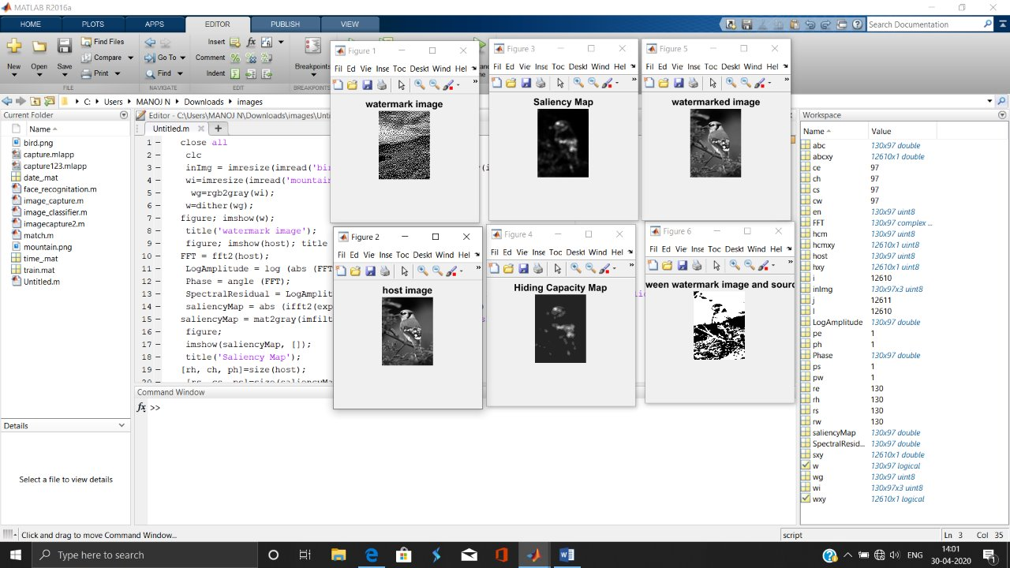

**PROPOSED ALGORITHM**

1.Read the info picture.

2.Convert this info picture into dark code/dim picture.

3. Resize this grey image.

4. Illustrate the difference between the black & white section where the difference is not noticeable.

5. Fourier transform of the source image.

6. Logarithmic value of absolute FT for each pixel.

7. Define the phase of each pixel for same FT value.

8. Calculate the Spectral Residual.

9. Find the Saliency Map of the original image.

10. Calculate the dimension for host, saliency map and host image.

11. Convert these three images into one dimension.

12. Create a blank image of dimension of source image.

13. Use ‘for loop’ for define the value difference for each pixel into the blank image.

14. Determine the corresponding HCM.

15. Now use another ‘for loop’ for bit set for the corresponding values of those pixel (2, 3, 4, 5).

16. Reshape the image into row, column and phase.

**MAT LAB FUNCTIONS**

**A = imread(filename, fmt)** peruses a grayscale or shading image from the record determined by the string computer filename. On the off probability that the record is not within the gift envelope, or in associate degree organizer on the MATLAB® approach, indicate the complete pathname.

The content string fmt indicates the organization of the record by its normal document augmentation. for example, indicate 'gif' for Graphics Interchange Format records. to visualize a summary of upheld teams, with their document augmentations, utilize the imformats work. within the event that imread cannot discover a document named computer filename, it searches for a record named computer filename.fmt.

The arrival esteem associate degree is associate degree exhibit containing the image data. On the off probability that the record contains a grayscale image, associate degree could be a M-by-N cluster. within the event that the record contains a TrueColor image, associate degree could be a M-by-N-by-3 exhibit.

**I = rgb2gray(RGB)**: changes over the TrueColor image RGB to the grayscale force image I. rgb2gray changes over RGB footage to grayscale by confiscating the tint and immersion information whereas holding the luminousness.

**BW = dither(I)**: changes over the grayscale image within the framework I to the paired (highly contrasting) image warfare by vacillant.

**subplot(m,n,p)**: isolates this contemplate in conjunction with a m-by-n lattice and makes a tomahawks within the framework position determined by p. MATLAB® numbers its networks by push, with the tip goal that the most matrix is that the principal section of the first line, the next lattice is that the second section of the principal push, etc.

**imshow(I)**: shows the image I during a Handle Graphics® figure, wherever I could be a grayscale, RGB (TrueColor), or double image. For twofold footage, imshow shows pixels with the price zero (zero) as dark and one as white.

**Y = fft2(X)**:returns the two-dimensional separate Fourier amendment (DFT) of X. The DFT is patterned with a fast Fourier amendment (FFT) calculation. the end result, Y, could be a similar size as X.

On the off probability that the spatiality of X is additional noteworthy than two, the fft2 work restores the 2-D DFT for every higher dimensional cut of X. for example, within the event that size(X) = [100 a hundred 3], at that time fft2 figures the DFT of X(:,:,1), X(:,:,2) and X(:,:,3).

**B = imfilter(A,h)** channels the two-dimensional exhibit A with the two-dimensional channel h. The exhibit A will be intelligent or a no inadequate numeric cluster of any category and measure. the end result B encompasses a similar size and sophistication as A.

**h = fspecial('average', hsize)** restores associate degree averaging channel h of size hsize. The competition hsize will be a vector deciding the amount of lines and sections in h, or it tends to be a scalar, during which case h could be a sq. network. The default associate degree incentive for hsize is [3 3].

**I = mat2gray(A, [amin amax])** changes over the lattice A to the facility image I. The came back lattice I contains values within the vary zero.0 (dark) to one.0 (full force or white). amin and amax ar the qualities during a that compare to zero.0 and 1.0 in I. Qualities not specifically amin become zero.0, and values additional noteworthy than amax become one.0.

**[r c p]=size()** restores the dimensions of line vector, section vector and no of planes of the knowledge image.

**B = reshape(A,m,n) or B = reshape(A,[m n])** restores the m-by-n framework B whose parts ar taken section smart from A. a slip-up results if A does not have m*n parts

**CONCLUSION**

The investigation of the watermark innovation has gotten dynamic since mid-1990s, and a few advancements are as of now embraced in pragmatic applications as an item or as exclusive administrations for endeavors.

In spite of the fact that this is a moderately new innovation region, it rapidly turns into a down to earth and powerful arrangement in some application territories, and has extraordinary potential for some different regions also.

The way in to the fruitful execution is to comprehend the focal points and the constraints of the watermark innovation, and to utilize the watermark innovation as a complimentary component to the current security components.